MINISTRY OF EDUCATION AND TRAINING VAN LANG UNIVERSITY
FACULTY OF MECHATRONICS AND COMPUTER ENGINEERING



CAPSTONE PROJECT – GROUP 15
Design and Development of a Simulation-Based Game
Application for Fire Prevention and Firefighting Training
Major: Software Engineering
Document:

SOFTWARE REQUIREMENTS SPECIFICATION

Version: 1.2 | Date created: January 12, 2026
Student Group:

BÙI LÊ ĐỨC HUY* | 2274801030183
BÙI LÊ ĐỨC HIẾU | 2274801030046
LÊ TUẤN ANH | 2274801030228

Mentor: MSc. Lã Hoàng Quý

Ho Chi Minh City – January 12, 2026

REVISION HISTORY
Project Information Overview
Project Title | Design and Development of a Simulation-Based Game Application for Fire Prevention and Firefighting Training
Product Name | Ignis Guard
Project Mentor | Ths. Lã Hoàng Quý
Partner Organization | No external partner organization
Team members | Bùi Lê Đức Huy* | 2274801030183
 | Bùi Lê Đức Hiếu | 2274801030046
 | Lê Tuấn Anh | 2274801030228

Document Information
Document Title | SOFTWARE REQUIREMENTS SPECIFICATION
Author(s), Role(s) | Bùi Lê Đức Huy | Team Leader, Unity Programmer, Game Designer, 3D Artist
 | Bùi Lê Đức Hiếu | Unity Programmer, Game Designer, UI/UX Designer, Writer/Content
 | Lê Tuấn Anh | Writer/Content, QA, Game Designer
Changelog | 12/1/2026 – v1.2 | Figures Added

TABLE OF CONTENTS
REVISION HISTORY 2
TABLE OF CONTENTS 3
LIST OF FIGURES 5
LIST OF TABLES 6
Chapter 1. INTRODUCTION 8
1.1 Purpose 8
1.2 Scope 8
1.3 Definitions, Acronyms, and References 8
1.3.1 Definitions 8
1.3.2 Acronyms 9
1.3.3 References 10
Chapter 2. SYSTEM CONTEXT / OVERALL DESCRIPTION 11
2.1 Product Perspective and Problem Context 11
2.2 System Context Diagram 11
2.3 System Boundary and Main Components 12
2.4 User Classes, Support Roles, and Stakeholders 13
2.5 Operating Environment 13
2.6 Assumptions and Constraints 14
Chapter 3. BUSINESS REQUIREMENTS 15
3.1 Business Goals 15
3.2 Business Constraints 15
3.3 Business Context and Success Criteria 15
Chapter 4. USER REQUIREMENTS 17
4.1 Actors 18
4.2 System Use Case Diagram 18
4.3 Use Case Overview 19
4.4 Detailed Use Case Descriptions 19
Chapter 5. SYSTEM & SOFTWARE REQUIREMENTS 32
5.1 Functional Requirements 32
5.2 Non-functional Requirements 34
5.3 External Interface Requirements 35
5.4 Component-specific Software Requirements 36
5.4.1 Gameplay Core Requirements 36
5.4.2 UI/HUD Requirements 37
5.4.3 AI & Telemetry Requirements 37
5.5 System Constraints 38
Chapter 6. APPENDIX / REFERENCE 39
6.1 Glossary 39
6.2 Requirement Traceability Matrix (RTM) 39
6.3 Reference Documents and Next-step Notes 40

LIST OF FIGURES
Figure 2.1 11

LIST OF TABLES
Table 1.1 Definitions 8
Table 1.2 Acronyms 9
Table 1.3 References 10
Table 2.1 Internal Components and Responsibilities 12
Table 2.2 User Classes, Support Roles, and Stakeholders 13
Table 3.1 Business Context and Success Criteria 15
Table 4.1 17
Table 4.2 Actors in User Requirements 18
Table 4.3 UC-01 — Start Game 20
Table 4.4 UC-02 — Access Tutorial 21
Table 4.5 UC-03 — Select Scenario 22
Table 4.6 UC-04 — Ask Emergency-call Questions in Call Phase 24
Table 4.7 UC-05 — Review Notepad and Incident Summary 24
Table 4.8 UC-06 — Review and Confirm Loadout 26
Table 4.9 UC-07 — Enter On-site Phase 27
Table 4.10 UC-08 — Move, Interact, and Use Firefighting Tools 28
Table 4.11 UC-09 — Execute Mission Objectives 30
Table 4.12 UC-10 — Issue Bot Commands 31
Table 4.13 UC-11 — Handle Hazards and Rescue Victims 34
Table 4.14 UC-12 — Receive Debrief and Rank414 36
Table 4.15 UC-13 — Replay or Exit Scenario 36
Table 4.16 UC-14 — Pause and Resume Mission 37
Table 4.17 UC-15 — Configure Game Settings 38
Table 4.18 UC-16 — Review Playtest Telemetry 39
Table 5.1 Functional Requirements 41
Table 5.2 Non-functional Requirements 43
Table 5.3 External Interface Requirements 44
Table 5.4 Gameplay Core Requirements 45
Table 5.5 UI/HUD Requirements 46
Table 5.6 AI & Telemetry Requirements 46
Table 5.7 System Constraints 47
Table 6.1 Glossary 48
Table 6.2 Requirement Traceability Matrix (RTM) 48

INTRODUCTION

Purpose
This Software Requirements Specification (SRS) document describes the requirements of the Ignis Guard system, a serious game for firefighting training simulation developed on the Unity platform. The purpose of this document is to align the scope, behavior, constraints, and verification criteria of the software among the development team, the project mentor, and the evaluation stakeholders.
This SRS is used as an input for the Software Design Specification (SDS) phase, test case development, milestone reviews, and assessment of product completeness throughout the Capstone Project. The requirements in this document are written in the spirit of IEEE 830 and follow the structure of the sample template, while being adjusted to fit a Unity game that runs locally on PC.

Scope
Ignis Guard is a first-person firefighting simulation game in which the player takes the role of a fire team leader who receives information from an emergency call, assesses the incident, selects a loadout, coordinates bot teammates, and carries out missions in a 3D on-site environment. The product's core loop consists of three phases: Call Phase, On-site Phase, and Result/Debrief.
Within the scope of the current Capstone version, the system focuses on two main scenarios: Urban High-rise and Suburban House. Core features include an emergency-call Q&A minigame, Incident State inference, loadout recommendation, an SOP-based mission tree, bot commands, safety penalties, cause-and-effect debriefing, and minimal logging for playtesting. Out-of-scope features include multiplayer/co-op, VR/mobile support, monetization, free-form NLP-based questioning, and professional certification-level training systems.

Definitions, Acronyms, and References

Definitions
Table 1.1 Definitions
Term | Definition
Scenario | A specific firefighting situation or mission level.
Call Phase | The phase in which the emergency call is received, questions are asked, and initial information is gathered.
Incident State | The incident status inferred from the Call Phase; in version 1, it includes smoke density, fire intensity, spread rate, and gas hazard.
Loadout | The set of equipment, supplies, or tools recommended before entering the scene, based on the Incident State and the scenario rule set.
On-site Phase | The gameplay phase at the scene in a first-person perspective.
Mission Tree | The set of main and side objectives generated according to the scenario and SOP rule set.
SOP | Standard Operating Procedure; the rule set that prioritizes safety and task handling.
Grade Lock | A mechanism that limits the maximum achievable rank when serious safety violations or critical procedural mistakes occur.
Debrief | The result summary screen showing the cause-and-effect timeline and score breakdown.
Telemetry | Playtest/runtime data stored locally for tuning, debugging, and milestone review purposes.

Acronyms
Table 1.2 Acronyms
Acronym | Meaning
SRS | Software Requirements Specification
SDS | Software Design Specification
FR | Functional Requirement
NFR | Non-functional Requirement
SWR | Software Requirement
RTM | Requirement Traceability Matrix
SOP | Standard Operating Procedure
UI | User Interface
HUD | Heads-Up Display
FPS | First-Person perspective
QA | Quality Assurance
VFX | Visual Effects
SFX | Sound Effects

References
Table 1.3 References
ID | Reference
[R1] | BAD/ConOps – Ignis Guard, current working version used by the team.
[R2] | Project Charter – Ignis Guard, version currently used by the team.
[R3] | Project Plan – Ignis Guard, version currently used by the team.
[R4] | Software Process and Quality Plan – Ignis Guard, version currently used by the team.
[R5] | Capstone Project Guidebook, Chapter 2, Chapter 3, and related appendices on SRS/SDS structure.
[R6] | IEEE Std 830-1998 and ISO/IEC 25010:2011, used as supporting references for software requirements specification and quality attributes.

SYSTEM CONTEXT / OVERALL DESCRIPTION

Product Perspective and Problem Context
At present, firefighting education and training mainly rely on theoretical materials, demonstration videos, and a limited number of field drills. This approach lacks interactivity, is difficult to repeat across multiple situations, and does not clearly show learners the cause-and-effect relationship between decisions and outcomes.
Ignis Guard is proposed as a simulation system that helps learners move from passive learning to the loop of gathering information → inferring the incident → making decisions → taking action → receiving consequences → reflecting. The primary target users are FFR trainees, while academic stakeholders and the development team use this document to review, validate, and refine the product. From a product perspective, this is a standalone system that runs locally and does not depend on an online backend in the Capstone version.

System Context Diagram
The figure below describes the system context of Ignis Guard at a high level and identifies the main external actors/entities that interact with the playable build.
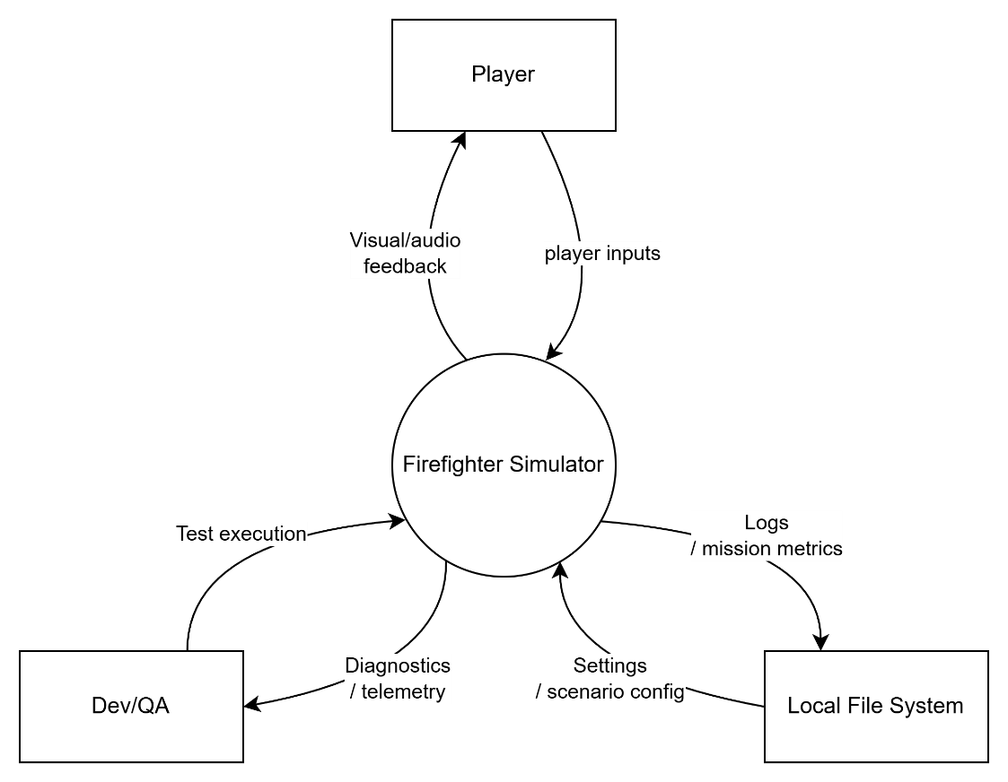
Figure 2.1. System Context Diagram – Ignis Guard
Figure 2.1 describes the system boundary of Ignis Guard at a high level. At this level of abstraction, the system is viewed as a standalone playable build, in which the Player is the primary actor, Dev/QA is the support actor, and the Local File System is an external entity used for configuration and local data storage. The diagram shows only the main interaction groups that cross the system boundary, such as player inputs, visual/audio feedback, test execution, diagnostics/telemetry, settings/scenario configuration, and persisted logs/mission metrics. Internal modules are not shown in this diagram and are described in the next section.

System Boundary and Main Components
Table 2.1 Internal Components and Responsibilities
Internal component | Responsibility
Game Client | Provides the menu, tutorial, runtime mission, HUD, pause menu, and debrief.
Call Phase Module | Displays emergency-call questions, enforces time/question limits, updates the notepad, and finalizes the initial information.
Incident Analysis & Loadout Engine | Infers the Incident State and generates the loadout summary before entering the scene.
Mission Tree & Rule Engine | Generates main and side objectives according to the scenario, SOP, and incident state.
Bot Command & AI Module | Receives the team leader's commands, coordinates bot behavior, and handles fallback cases.
Debrief & Scoring Module | Calculates the score, checks the grade lock, and displays the cause-and-effect timeline and rank.
Local Logging / Telemetry | Stores playtest data, build version, settings, and mission metrics in local storage.

User Classes, Support Roles, and Stakeholders
Table 2.2 User Classes, Support Roles, and Stakeholders
Role / class | Relationship to system
Player | Primary end-user role; mainly represents FFR trainees who select scenarios, complete missions, issue bot commands, and review debrief/replay results.
Dev/QA | Internal support actor; runs the build, accesses telemetry/logs, performs smoke tests, and tunes the game after playtesting.
Mentor/Instructor (stakeholder) | Indirect stakeholder; reviews training logic, educational value, and milestone/demo outcomes rather than operating the runtime as a direct gameplay actor.
Runtime Environment / Local File System | Non-actor external entity; provides the build runtime environment and the location for storing local settings, logs, and mission data.

Operating Environment
- Runtime target: PC/Windows with keyboard and mouse as the default input interface; controller mapping is optional.
- Game engine: Unity; the product is deployed as a playable build for demos and internal playtesting.
- Local data: settings, mission configuration, and telemetry are stored locally (for example, JSON/CSV/ScriptableObject-backed data).
- Support environment: Git, sprint-based build sharing workflow, and a demo PC/projection setup for milestone reviews.

Assumptions and Constraints
- The current Capstone version supports single-player only; there is no multiplayer/co-op.
- Incident State v1 includes only four main variables: smoke density, fire intensity, spread rate, and gas hazard.
- The team prioritizes completing an end-to-end core loop and two playable scenarios before expanding features.
- VR/mobile support, monetization, certification training, and free-form NLP are outside the current scope.
- If the Call Phase runs out of time or available questions, the system must finalize the currently available information and accept a potentially non-optimal loadout.

BUSINESS REQUIREMENTS

Business Goals
- Provide a safe, highly interactive firefighting simulation environment that can be replayed many times.
- Recreate the firefighting response process through the loop Call Phase → On-site Phase → Result/Debrief.
- Help learners practice observation, decision-making, tactical coordination, and post-action reflection.
- Support at least two representative scenarios sufficient for demos and basic learning-outcome evaluation.

Business Constraints
- The project is carried out within the Capstone scope and is therefore constrained by time, manpower, and technical resources; as a result, the team prioritizes a playable vertical slice rather than expanding into a complete training platform.
- The current version targets only a standalone single-player build running locally on PC/Windows; multiplayer/co-op, online backend, VR/mobile, and commercialization features are outside the implementation scope.
- The simulation level prioritizes learning value and procedural consistency over fully reproducing a real-world professional training environment.
- The content of the first version is limited to two main scenarios, a reduced Incident State set, and rule-based gameplay logic in order to complete the end-to-end core loop within the Capstone timeline.
- Playtest data, settings, and mission metrics are stored locally; the system does not aim to integrate data analytics infrastructure or user management at this stage.

Business Context and Success Criteria
Table 3.1 Business Context and Success Criteria
Item | Statement
Primary business problem | Current firefighting learning methods remain passive, difficult to reproduce, costly, and lacking in cause-and-effect feedback.
Project focus | Prioritize a playable build that demonstrates learning value and procedural thinking rather than expanding the platform's scale.
Success criterion SC-01 | Complete one end-to-end core loop in each of the two scenarios without requiring a game restart or developer intervention.
Success criterion SC-02 | The build shall provide two playable scenarios, Urban High-rise and Suburban House, and each scenario shall progress from scenario selection to the Debrief screen.
Success criterion SC-03 | For both scenarios, the mission tree, loadout recommendation, bot commands, safety handling, and debrief shall behave according to the defined rule set under normal playtest conditions.
Success criterion SC-04 | The Debrief shall display at minimum the mission outcome, completed objectives, major penalties, final rank, and a cause-and-effect timeline so that testers can identify why the result was achieved.
Success criterion SC-05 | The system shall store, in local output accessible to Dev/QA, at minimum the scenario, build version, mission result, major penalties, and final rank for each playtest run.
Success criterion SC-06 | On the reference demo machine, the build shall complete at least five consecutive demo runs without blocker crashes and without requiring an online backend or complex operational setup.

USER REQUIREMENTS
Table 4.1
ID | Use case | Primary actor | Expected outcome
UC-01 | Start Game | Player | The game launches into the Main Menu reliably.
UC-02 | Access Tutorial | Player | The player learns the basic controls and interactions.
UC-03 | Select Scenario | Player | Select a scenario to enter the Call Phase.
UC-04 | Ask Emergency-call Questions in Call Phase | Player | Collect initial data within the time/question limit.
UC-05 | Review Notepad and Incident Summary | Player | Review the gathered information and the provisional Incident State.
UC-06 | Review and Confirm Loadout | Player | Confirm the loadout recommended by the system.
UC-07 | Enter On-site Phase | Player | Enter the on-site runtime mission.
UC-08 | Move, Interact, and Use Firefighting Tools | Player | Control the character and use firefighting tools in the 3D scene.
UC-09 | Execute Mission Objectives | Player | Complete the main and side objectives according to the SOP.
UC-10 | Issue Bot Commands | Player | Coordinate bots to support searching, extinguishing, rescue, or carrying supplies.
UC-11 | Handle Hazards and Rescue Victims | Player | Handle gas hazards, smoke/fire spread, and rescue victims.
UC-12 | Receive Debrief and Rank | Player | Receive the score breakdown, rank, and cause-and-effect timeline.
UC-13 | Replay or Exit Scenario | Player | Replay the scenario or exit to the menu.
UC-14 | Pause and Resume Mission | Player | Pause the mission safely and resume with the mission state preserved.
UC-15 | Configure Game Settings | Player | Adjust audio, display, and basic controls.
UC-16 | Review Playtest Telemetry | Dev/QA | Dev/QA can access the log/summary after each playtest session to compare builds and tuning results.

Actors
The User Requirements section records only actors that actually initiate or pursue a goal external to the system. In the current version, the Player is the primary actor because they directly interact with the gameplay from menu to debrief; this actor mainly represents the target user group of FFR trainees. Dev/QA is a support actor because they use the build for playtesting, review telemetry, and support tuning between milestones. Mentor/Instructor is considered an indirect stakeholder for review/demo purposes, but is not modeled as a direct use-case actor within the scope of Section IV.
Table 4.2 Actors in User Requirements
Actor | Role in user requirements
Player | Primary actor; represents the end user in runtime interactions and mainly reflects the intended FFR trainee audience.
Dev/QA | Support actor; runs the build, performs smoke tests, accesses telemetry/logs, and compares results across playtest sessions.
Mentor/Instructor | Indirect stakeholder; observes demos and reviews educational outcomes, but does not directly initiate in-scope runtime use cases.

System Use Case Diagram
The figure below provides an overview of the main use cases of Ignis Guard at the user-interaction level. At this level, the Player is the main actor interacting with gameplay/runtime, while Dev/QA participates only in the support use case after playtesting to review telemetry and log output. The diagram is used to illustrate the scope of the User Requirements before the overview table and detailed use-case descriptions.
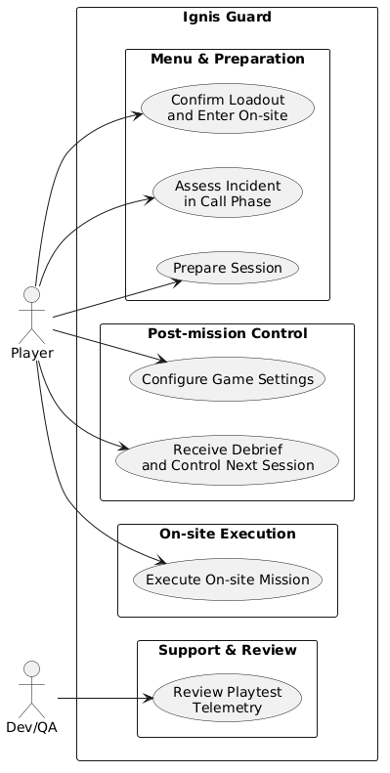
Figure X. System Use Case Diagram – Ignis Guard
This use case diagram shows only goal-oriented interactions at the user/support level and does not describe the internal modules of the system.

Use Case Overview
The table below summarizes all use cases within the scope of the current version. To make the user journey easier to follow, the use cases are understood in four main groups:
(1) Menu and preparation, from launching the game to confirming the loadout;
(2) On-site execution, from entering the scene to completing objectives and handling hazards;
(3) Post-mission control, including debrief, replay/exit, and settings;
(4) Support and review for Dev/QA after playtesting.

UC-01 to UC-15 describe the Player's direct interactions with gameplay/runtime; UC-16 is a support use case for Dev/QA to access telemetry after playtesting.

Detailed Use Case Descriptions
Each use case below is described at a level concise enough for traceability while still preserving the logic of user interaction. For each use case, the document clearly identifies the actor, trigger, preconditions, main success flow, alternative/exception flows, postconditions, and related requirements. These flows are written for the current Capstone version and do not include out-of-scope features such as multiplayer, online backend, VR/mobile, or free-form NLP.
UC-01 — Start Game
Table 4.3 UC-01 — Start Game
Use Case ID | UC-01
Use Case Name | Start Game
Primary Actor | Player
Trigger | The player runs the game executable.
Preconditions | The build has been installed or copied correctly; the required runtime files exist.
Main Success Flow | 1. The system loads the required startup assets and scenes.  2. The splash/title screen shall be displayed within <= 3 seconds on the reference demo machine after the executable starts.  3. The Main Menu appears with Start/Scenario, Tutorial, Settings, and Quit.  4. The player can navigate the menu using keyboard/mouse.
Alternative / Exception Flows | • If startup asset initialization fails, the system shall display an error dialog containing an error code and return to desktop or retry screen within <= 5 seconds, without freezing input for more than 1 second.  • If the game is reopened after a previous session, the saved settings are loaded before the menu is shown.
Postconditions | The Main Menu is displayed stably and the player can continue to the Tutorial or Scenario Select.
Related Requirements | FR-01, FR-15, SWR-U-01

UC-02 — Access Tutorial
Table 4.4 UC-02 — Access Tutorial
Use Case ID | UC-02
Use Case Name | Access Tutorial
Primary Actor | Player
Trigger | The player selects Tutorial from the Main Menu.
Preconditions | The game has reached the Main Menu.
Main Success Flow | 1. The system loads the Tutorial scene or a short training module.  2. The HUD displays prompts for movement, camera look, interaction, and tool use.  3. The player completes each step in the checklist.  4. Each completed step is acknowledged with text or an audio cue.  5. When the checklist is complete, the system suggests entering the main mission.
Alternative / Exception Flows | • The player may skip the Tutorial and return to the menu.  • If the player does not complete the current tutorial step within 20 seconds, the system shall replay the instruction once and highlight the relevant control prompt.
Postconditions | The basic-control checklist is completed, or the player exits the Tutorial and returns to the menu.
Related Requirements | FR-02, FR-09, NFR-06, SWR-U-02

UC-03 — Select Scenario
Table 4.5 UC-03 — Select Scenario
Use Case ID | UC-03
Use Case Name | Select Scenario
Primary Actor | Player
Trigger | The player selects Start Mission or Scenario Select.
Preconditions | The game is currently at the Main Menu.
Main Success Flow | 1. The list of available scenarios is displayed, including at least Urban High-rise and Suburban House.  2. The player reviews a short summary of each scenario.  3. The player selects a scenario.  4. The system confirms the selection and transitions to the Call Phase.
Alternative / Exception Flows | • If a scenario is not unlocked or not ready, the system disables the selection and displays the reason.  • The player can return to the Main Menu without changing the saved state.
Postconditions | The scenario is finalized and the system transitions to the corresponding Call Phase.
Related Requirements | FR-03, FR-04, SWR-U-01

UC-04 — Ask Emergency-call Questions in Call Phase
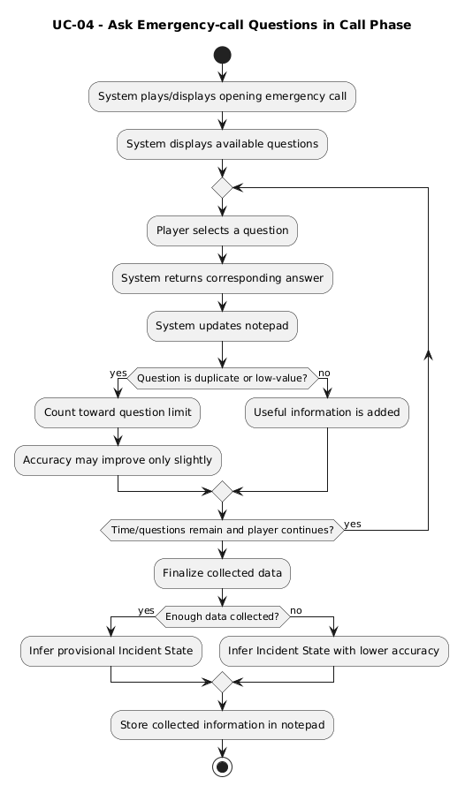
Table 4.6 UC-04 — Ask Emergency-call Questions in Call Phase
Use Case ID | UC-04
Use Case Name | Ask Emergency-call Questions in Call Phase
Primary Actor | Player
Trigger | The Call Phase begins after a scenario is selected.
Preconditions | A valid scenario has been selected.
Main Success Flow | 1. The system plays or displays the opening emergency call.  2. The list of available questions is displayed.  3. The player selects questions within the time limit or question limit.  4. The system returns the corresponding answers and updates the notepad.  5. When time/questions run out or the player ends early, the system finalizes the collected data.
Alternative / Exception Flows | • If time/questions run out before enough data is collected, the Incident State is still inferred from the available information and may be less accurate.  • If the player asks duplicate or low-value questions, the system still counts them toward the question limit but they may not significantly improve accuracy.
Postconditions | The collected information is stored in the notepad; the system has enough data to finalize the provisional Incident State.
Related Requirements | FR-04, FR-05, FR-06, SWR-G-01

UC-05 — Review Notepad and Incident Summary
Table 4.7 UC-05 — Review Notepad and Incident Summary
Use Case ID | UC-05
Use Case Name | Review Notepad and Incident Summary
Primary Actor | Player
Trigger | The player opens the notepad during or at the end of the Call Phase.
Preconditions | At least one piece of information has been collected from the Call Phase.
Main Success Flow | 1. The player opens the notepad or summary panel.  2. The notepad/summary panel shall display each collected clue as a separate labeled entry with category, source question, and current inferred incident value.  3. The provisional Incident State is summarized with clear indicators.  4. The player reviews the information and prepares for the loadout step.
Alternative / Exception Flows | • If one or more required incident variables are missing, the summary panel shall display the status ‘Incomplete Data’ and show a visible warning icon next to each inferred low-confidence field.
Postconditions | The player understands the available information and the provisional incident status before confirming the loadout.
Related Requirements | FR-05, FR-06, SWR-U-03

UC-06 — Review and Confirm Loadout
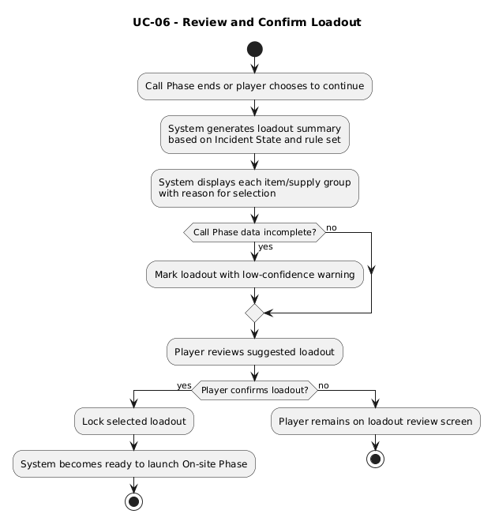
Table 4.8 UC-06 — Review and Confirm Loadout
Use Case ID | UC-06
Use Case Name | Review and Confirm Loadout
Primary Actor | Player
Trigger | The Call Phase ends or the player chooses to continue.
Preconditions | The Incident State has been inferred at the minimum required level.
Main Success Flow | 1. The system generates the loadout summary based on the Incident State and rule set.  2. Each item or supply group is displayed together with the reason for selection.  3. The player reviews the suggested loadout.  4. The player confirms the loadout to enter the mission.
Alternative / Exception Flows | • If fewer than 70% of required Call Phase data points are collected, the loadout summary shall show the label ‘Low Confidence Recommendation’ and list at least one missing-data reason.  • The player may not deeply customize the loadout in v1 if that functionality is outside scope.
Postconditions | The loadout is confirmed and the system is ready to launch the On-site Phase.
Related Requirements | FR-07, SWR-G-02

UC-07 — Enter On-site Phase
Table 4.9 UC-07 — Enter On-site Phase
Use Case ID | UC-07
Use Case Name | Enter On-site Phase
Primary Actor | Player
Trigger | The player confirms the loadout.
Preconditions | The scenario and loadout have been finalized.
Main Success Flow | 1. The system loads the on-site scene corresponding to the scenario.  2. The player spawns at a valid starting point.  3. The HUD displays the objective tracker, tool status, and required prompts.  4. The initial mission tree is activated.
Alternative / Exception Flows | • If the scene fails to load successfully, the system must return to a safe state instead of hanging the build.  • On the first run, the system may display a short SOP reminder or tutorial prompt.
Postconditions | The player is placed into the on-site scene with the HUD and mission tree functioning.
Related Requirements | FR-08, SWR-U-03, SWR-G-03

UC-08 — Move, Interact, and Use Firefighting Tools
Table 4.10 UC-08 — Move, Interact, and Use Firefighting Tools
Use Case ID | UC-08
Use Case Name | Move, Interact, and Use Firefighting Tools
Primary Actor | Player
Trigger | The player is in the On-site Phase.
Preconditions | The player has spawned into the runtime mission.
Main Success Flow | 1. The player controls the character to move and observe the environment.  2. The player interacts with doors, objects, mission areas, or victims.  3. The player uses firefighting tools according to the scenario design.  4. The system responds with animation, SFX, VFX, and appropriate environment-state changes.
Alternative / Exception Flows | • If the player attempts an invalid action, the system shall display a contextual failure cue within <= 0.5 seconds.  • If performance drops in areas with dense smoke/fire, the system must still maintain acceptable visibility and controllability.
Postconditions | The player successfully performs movement, interaction, and tool-use actions in gameplay.
Related Requirements | FR-09, NFR-01, NFR-02, SWR-G-04

UC-09 — Execute Mission Objectives
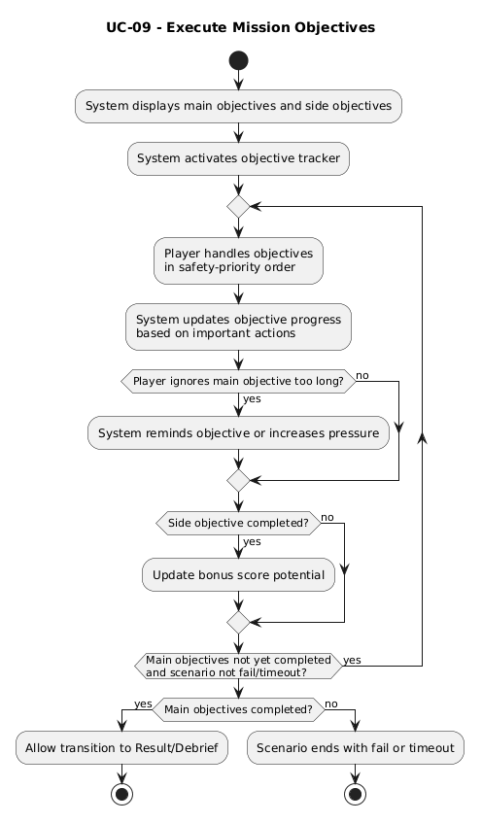
Table 4.11 UC-09 — Execute Mission Objectives
Use Case ID | UC-09
Use Case Name | Execute Mission Objectives
Primary Actor | Player
Trigger | The mission tree is active during the On-site Phase.
Preconditions | The scenario has started; the objective tracker is fully displayed.
Main Success Flow | 1. The system displays the main objectives and side objectives according to the scenario rule set.  2. The player handles the objectives in safety-priority order.  3. Objective progress is updated based on each important action.  4. When the main objectives are completed, the system allows transition to Result/Debrief.
Alternative / Exception Flows | • If the player ignores the main objective for too long, the system reminds the objective or increases pressure according to scenario logic.  • Side objectives are not required to complete the mission, but they affect the score and the chance of achieving rank S.
Postconditions | The main objectives are completed, or the scenario ends with a fail/timeout state.
Related Requirements | FR-10, FR-17, SWR-G-03

UC-10 — Issue Bot Commands
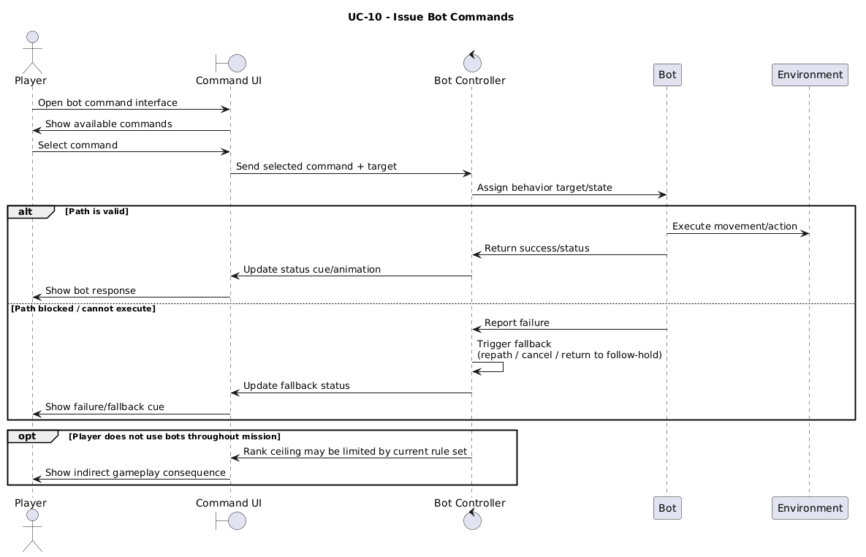
Table 4.12 UC-10 — Issue Bot Commands
Use Case ID | UC-10
Use Case Name | Issue Bot Commands
Primary Actor | Player
Trigger | The player looks at a bot or opens the command interface.
Preconditions | At least one bot is available in the mission.
Main Success Flow | 1. The player opens the bot command interface.  2. The player selects an appropriate command such as follow, hold, search, extinguish, carry victim, or bring supply.  3. The system assigns the behavior target to the bot.  4. The bot executes the command and responds with animation or a status cue.
Alternative / Exception Flows | • If a bot cannot execute a command because of path blockage, the system triggers a fallback such as repath, cancel command, or return to follow/hold.  • If the player does not use bots throughout the mission, the maximum achievable rank may be limited by the current rule set.
Postconditions | The bot receives the command and switches to the corresponding behavior state.
Related Requirements | FR-11, NFR-04, SWR-A-01, SWR-A-02

UC-11 — Handle Hazards and Rescue Victims
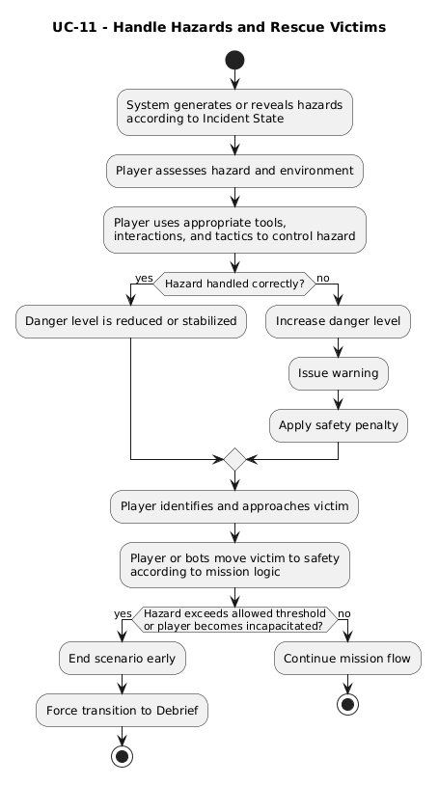
Table 4.13 UC-11 — Handle Hazards and Rescue Victims
Use Case ID | UC-11
Use Case Name | Handle Hazards and Rescue Victims
Primary Actor | Player
Trigger | The mission tree or environment generates a hazard/victim event.
Preconditions | The player is currently in the On-site Phase.
Main Success Flow | 1. The system generates or reveals hazards such as smoke, fire spread, or gas-related risk according to the Incident State.  2. The player uses appropriate tools, interactions, and tactics to control the hazard.  3. The player identifies and approaches the victim.  4. The player or bots move the victim to safety according to the mission logic.
Alternative / Exception Flows | • If the player handles an important hazard incorrectly, the system increases the danger level, issues a warning, and applies a safety penalty.  • If a hazard exceeds the allowed threshold or the player becomes incapacitated, the scenario may end early but must still proceed to Debrief.
Postconditions | The hazard is controlled to the required level and the victim is handled according to the scenario design.
Related Requirements | FR-12, FR-17, SWR-G-05

UC-12 — Receive Debrief and Rank
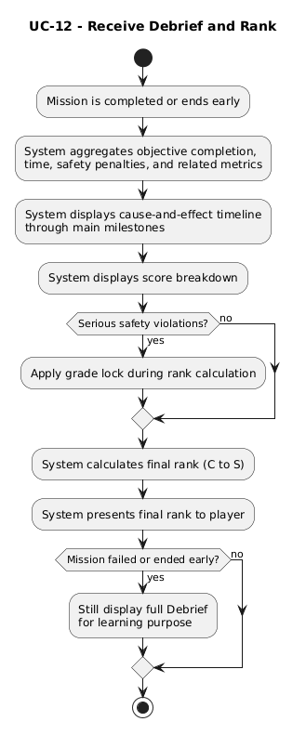
Table 4.14 UC-12 — Receive Debrief and Rank414
Use Case ID | UC-12
Use Case Name | Receive Debrief and Rank
Primary Actor | Player
Trigger | The mission is completed or ends early.
Preconditions | The scenario has finalized its result as success, fail, or timeout.
Main Success Flow | 1. The system aggregates objective completion, time, safety penalties, and related metrics.  2. The cause-and-effect timeline is displayed through the main milestones.  3. The score breakdown and final rank are presented clearly.  4. If there are serious safety violations, the grade lock is applied when calculating the rank.
Alternative / Exception Flows | • Even if the mission fails or ends early, the system must still display the Debrief to ensure the learning objective.
Postconditions | The player receives the score breakdown, cause-and-effect timeline, and rank from C to S.
Related Requirements | FR-13, FR-17, SWR-G-06, SWR-U-04

UC-13 — Replay or Exit Scenario
Table 4.15 UC-13 — Replay or Exit Scenario
Use Case ID | UC-13
Use Case Name | Replay or Exit Scenario
Primary Actor | Player
Trigger | The player is on the Debrief screen.
Preconditions | The Debrief has been fully displayed.
Main Success Flow | 1. The player selects Replay Scenario or Exit to Menu.  2. If Replay is selected, the system resets the mission state and returns to the appropriate scenario-selection/Call Phase flow.  3. If Exit is selected, the system releases the necessary resources and returns to the Main Menu.
Alternative / Exception Flows | • If telemetry data needs to be written, the system completes the write operation before leaving the Debrief screen.
Postconditions | The scenario is restarted from the beginning, or the player returns to the Main Menu.
Related Requirements | FR-14, SWR-U-04

UC-14 — Pause and Resume Mission
Table 4.16 UC-14 — Pause and Resume Mission
Use Case ID | UC-14
Use Case Name | Pause and Resume Mission
Primary Actor | Player
Trigger | The player opens the Pause Menu during the On-site Phase or during an active runtime mission.
Preconditions | The game is in a valid mission runtime state; the player is not in debrief or a loading transition.
Main Success Flow | 1. The player triggers pause.  2. The system stops gameplay updates within the designed scope and displays the Pause Menu.  3. The player reviews the current objectives or selects Resume.  4. The system continues the mission with the mission state, objective state, and HUD properly restored.
Alternative / Exception Flows | • If pausing is blocked during a transition moment or short cut-in, the system must show a short notice or ignore the request until runtime becomes stable.  • If the player selects Settings from the Pause Menu, the flow transitions to UC-15 and then returns to the Pause Menu or mission.
Postconditions | The mission is resumed safely without losing progress, objective state, or required HUD state.
Related Requirements | FR-15, NFR-03, SWR-U-06

UC-15 — Configure Game Settings
Table 4.17 UC-15 — Configure Game Settings
Use Case ID | UC-15
Use Case Name | Configure Game Settings
Primary Actor | Player
Trigger | The player opens Settings from the Main Menu or Pause Menu.
Preconditions | The game is in a menu or has been validly paused.
Main Success Flow | 1. The player opens Settings.  2. The system displays setting groups such as audio, display, control, and basic gameplay assist.  3. The player changes one or more parameters.  4. The system applies the settings and saves them locally if supported.
Alternative / Exception Flows | • If a new value is invalid or incompatible with the current runtime, the system restores the nearest safe value and informs the player.
Postconditions | The new configuration is applied immediately or after confirmation, and may be stored locally.
Related Requirements | FR-16, NFR-05, SWR-U-05

UC-16 — Review Playtest Telemetry
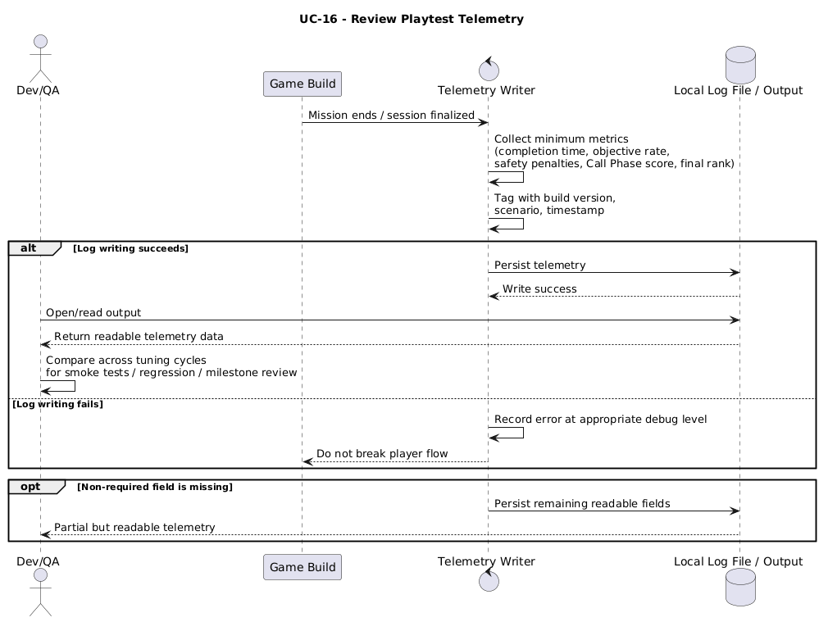
Table 4.18 UC-16 — Review Playtest Telemetry
Use Case ID | UC-16
Use Case Name | Review Playtest Telemetry
Primary Actor | Dev/QA
Trigger | A playtest session ends or Dev/QA opens the output folder/log after the build has written the data.
Preconditions | The build allows local logging; the play session has just generated the minimum gameplay data.
Main Success Flow | 1. After the mission ends, the system persists playtest metrics such as completion time, objective rate, safety penalties, Call Phase score, and final rank.  2. The data is tagged with build version, scenario, and timestamp.  3. Dev/QA accesses the designated log file or output to read/compare data across tuning cycles.  4. Dev/QA uses this data for smoke tests, regression notes, or milestone reviews.
Alternative / Exception Flows | • If log writing fails, the system must not break the player flow and must record the error at an appropriate debug level.  • If telemetry is missing a non-required field, the file must still remain readable for the remaining fields.
Postconditions | The minimum telemetry is persisted in a location accessible to Dev/QA to support tuning, comparison, and milestone reviews.
Related Requirements | FR-17, NFR-03, SWR-A-03, SWR-A-04

SYSTEM & SOFTWARE REQUIREMENTS

Functional Requirements
Table 5.1 Functional Requirements
ID | Functional requirement | Source UC | Verification hint
FR-01 | The system shall simulate hazard and rescue events including smoke, fire, gas-related risk, and victim incidents, and shall allow the player to respond to these events within the defined scope of each scenario. | UC-01 | Playtest scripted hazard and rescue cases in both scenarios..
FR-02 | The system shall provide a Tutorial/Training mode for players to learn the basic actions before entering a mission. | UC-02 | The tutorial checklist can be completed by a new player.
FR-03 | The system shall allow selection of at least 2 scenarios: Urban High-rise and Suburban House. | UC-03 | Check the menu and verify that the correct scenario is loaded.
FR-04 | The system shall provide the Call Phase as a list of emergency-call questions with a time limit or question limit. | UC-04 | Review Call Phase gameplay.
FR-05 | The system shall automatically update the notepad from the gathered information and allow the player to review the summary. | UC-04, UC-05 | Observe the UI after each question.
FR-06 | The system shall infer an Incident State that includes at least smoke density, fire intensity, spread rate, and gas hazard. | UC-04, UC-05 | Compare the output with the scenario data.
FR-07 | The system shall generate a loadout summary before the On-site Phase and state the main reasons for the selection. | UC-06 | Check the recommendation logic against the scenario/incident state.
FR-08 | The system shall allow entry into the On-site Phase with the HUD and mission tree initialized correctly. | UC-07 | Run an end-to-end flow from Call to On-site.
FR-09 | The system shall support movement, interaction, and tool use in FPS gameplay. | UC-08 | Playtest character actions and tools.
FR-10 | The system shall generate and update a mission tree consisting of main objectives and side objectives according to the rule set. | UC-09 | Check the objective flow in 2 scenarios.
FR-11 | The system shall support at minimum the bot commands follow, hold, search, extinguish, carry victim, and bring supply. | UC-10 | Playtest the command wheel / command UI.
FR-12 | The system shall simulate hazards and rescue flow sufficiently for the player to handle gas/fire/smoke risks and victims within the scenario scope. | UC-11 | Playtest edge cases and hazard handling.
FR-13 | The system shall always display the Debrief after a mission, including the score breakdown, cause-and-effect timeline, and rank C→S. | UC-12 | Check end states for success/fail/timeout.
FR-14 | The system shall allow Replay Scenario or Exit to Menu after the Debrief. | UC-13 | Check the replay/exit flow.
FR-15 | The system shall allow the player to pause and resume a mission without losing the local mission state, objective state, or required HUD context. | UC-14 | Pause/resume during gameplay and verify that the state is preserved correctly.
FR-16 | The system shall allow adjustment of basic Settings and save them locally if the save feature is enabled. | UC-15 | Change settings and restart the build.
FR-17 | The system shall persist minimum local telemetry for playtesting/tuning by build version and store it in a location accessible to Dev/QA. | UC-16 | Check the log file, output path, or serialized summary.
FR-18 | The system shall apply safety penalties and a grade lock when the player commits serious safety violations. | UC-09, UC-11, UC-12 | Check the scoring rubric using sample violations.

Non-functional Requirements
Table 5.2 Non-functional Requirements
ID | Category | Target statement | Verification
NFR-01 | Performance | On the reference demo machine, gameplay shall average >= 60 FPS under normal conditions and shall not drop below 30 FPS for more than 3 seconds in high-load situations within the design scope. | Performance test on 2 scenarios.
NFR-02 | Readability / Usability | Objective markers, hazard cues, and prompts shall remain readable at 1920x1080 with smoke/fire effects at the designed level. | Visual inspection + tester feedback.
NFR-03 | Stability | The build shall complete at least 5 consecutive core-loop runs without a blocker crash. | Smoke test regression.
NFR-04 | Bot Robustness | When bot pathfinding fails, the system shall trigger a fallback within <= 5 seconds or allow the command to be canceled without causing a soft lock. | Edge-case playtest.
NFR-05 | Maintainability | Mission data, question banks, and scoring thresholds shall be stored in separate configurable data assets or files so that ordinary content tuning can be performed without modifying gameplay scripts. | Change one mission-data item, one question-bank entry, and one scoring threshold without editing gameplay code.
NFR-06 | Learnability | A new player shall be able to complete the tutorial and understand the basic core loop within <= 5 minutes. | Playtest with a new player.
NFR-07 | Compatibility | The target build shall run on Windows 10/11 in the team's demo environment. | Install/run test on the target OS.

External Interface Requirements
Table 5.3 External Interface Requirements
Interface | Requirement
IF-01 Input Interface | Keyboard/mouse shall be the default input method for movement, interaction, tool use, menu navigation, and pause; controller mapping is an optional, non-mandatory feature.
IF-02 Call Phase UI | The Call Phase interface shall display the question list, time/question counter, notepad, and summary panel in a readable manner.
IF-03 On-site HUD | The On-site HUD shall display the objective tracker, mission tree, tool status, warning/hazard cues, and the prompts required for gameplay.
IF-04 Bot Command UI | The system shall provide a command interface for the commands follow, hold, search, extinguish, carry victim, and bring supply.
IF-05 Audio/Visual Feedback | The system shall provide at minimum audio cues and visual feedback for alarms, fire, interaction success/failure, safety warnings, and debrief emphasis.
IF-06 Data/File Interface | Settings, mission data, and telemetry shall be stored locally in a consistent format and be readable/comparable by the development team during playtesting.

Component-specific Software Requirements
This section specifies the software requirements by the main component groups of the Unity game architecture within the Capstone scope, including Gameplay Core, UI/HUD, and AI & Telemetry. The requirements below support the transition to the SDS and do not replace the system-level Functional Requirements.

Gameplay Core Requirements
Table 5.4 Gameplay Core Requirements
ID | Requirement
SWR-G-01 | The Call Phase logic shall read data from the question bank/scenario data and update the notepad after each question.
SWR-G-02 | The loadout engine shall map the Incident State to a minimum equipment/supply list and preserve the corresponding recommendation basis.
SWR-G-03 | The mission tree engine shall distinguish between main objectives and side objectives, and support mission-completion conditions.
SWR-G-04 | Tool interaction shall update the corresponding environment state or objective state when used in the proper context.
SWR-G-05 | Hazard handling shall reflect at least smoke/fire spread and gas-related risk within the scenario design scope.
SWR-G-06 | The scoring module shall combine objective results, mission time, safety penalties, and the grade lock to calculate the final rank.

UI/HUD Requirements
Table 5.5 UI/HUD Requirements
ID | Requirement
SWR-U-01 | The Main Menu shall provide Start/Scenario, Tutorial, Settings, and Quit with a clear navigation flow.
SWR-U-02 | Tutorial prompts shall be displayed in checklist order and disappear when the corresponding step is completed.
SWR-U-03 | The On-site HUD shall prioritize readability in smoke/fire environments; the objective tracker must not excessively obstruct vision.
SWR-U-04 | The Debrief screen shall display the cause-and-effect timeline, score breakdown, rank, and Replay/Exit options.
SWR-U-05 | The Settings screen shall allow saving and reloading at least the basic settings if the save feature is enabled.
SWR-U-06 | The Pause Menu shall pause runtime within the designed scope, allow safe resume, and not corrupt the mission state or objective tracking.

AI & Telemetry Requirements
Table 5.6 AI & Telemetry Requirements
ID | Requirement
SWR-A-01 | The bot command module shall translate commands from the command interface into the corresponding bot state or behavior.
SWR-A-02 | Bots shall have a fallback for cases where pathfinding fails or a command cannot be executed as expected.
SWR-A-03 | The telemetry module shall store at minimum the scenario, build version, mission time, objective completion, safety penalties, and final rank in an output accessible to Dev/QA.
SWR-A-04 | Telemetry write failures shall not interrupt the player flow or corrupt the build/runtime state.

System Constraints
Table 5.7 System Constraints
ID | Constraint area | Statement
C-01 | Platform scope | The current Capstone version supports PC/Windows only.
C-02 | Feature scope | The system does not support multiplayer/co-op, VR/mobile, monetization, or free-form NLP in the current scope.
C-03 | Project scope | The team prioritizes completing the end-to-end core loop, the two main scenarios, and the playable build used for milestone/demo purposes before expanding features.
C-04 | Technical scope | Incident State v1 is limited to four main variables; bot AI is only at the level of basic tactical support in the current version.

APPENDIX / REFERENCE

Glossary
Table 6.1 Glossary
Term | Meaning in this SRS
Scenario | A specific firefighting situation or mission level.
Call Phase | The phase in which the emergency call is received, questions are asked, and initial information is gathered.
Incident State | The incident status inferred from the Call Phase; in version 1, it includes smoke density, fire intensity, spread rate, and gas hazard.
On-site Phase | The gameplay phase at the scene in a first-person perspective.
Mission Tree | The set of main and side objectives generated according to the scenario and SOP rule set.
SOP | Standard Operating Procedure; the rule set that prioritizes safety and task handling.
Grade Lock | A mechanism that limits the maximum achievable rank when serious safety violations occur.
Debrief | The result summary screen showing the cause-and-effect timeline and score breakdown.

Requirement Traceability Matrix (RTM)
Table 6.2 Requirement Traceability Matrix (RTM)
Business goal | Use cases | Functional req. | Software req. | Indicative test cases
BG-01 Safe interactive training | UC-02, UC-08, UC-11, UC-12 | FR-02, FR-09, FR-12, FR-13, FR-17 | SWR-G-04, SWR-G-05, SWR-G-06 | TC-TUT-01, TC-MIS-02, TC-DEB-01
BG-02 Three-phase learning loop | UC-04, UC-06, UC-07, UC-12 | FR-04, FR-06, FR-07, FR-08, FR-13 | SWR-G-01, SWR-G-02, SWR-U-04 | TC-CALL-01, TC-LOAD-01, TC-DEB-02
BG-03 Tactical coordination | UC-09, UC-10, UC-11 | FR-10, FR-11, FR-12, FR-17 | SWR-G-03, SWR-A-01, SWR-A-02 | TC-MIS-01, TC-BOT-01
BG-04 Replay and reflective learning | UC-12, UC-13, UC-14 | FR-13, FR-14, FR-15 | SWR-G-06, SWR-U-04, SWR-U-06 | TC-DEB-03, TC-REP-01, TC-PAU-01
BG-05 Build/playtest tuning | UC-16 | FR-17 | SWR-A-03, SWR-A-04 | TC-LOG-01

Reference Documents and Next-step Notes
- Primary sources: the current BAD/ConOps, Project Charter, Project Plan, and Software Process and Quality Plan of Ignis Guard used by the team as the active project baseline.
- Method source: Capstone Project Guidebook, especially the sections on SRS, traceability, and downstream transition to SDS / test-case design.
- Recommended next step: continue decomposing this SRS into SDS / Architecture Design, Architecture Drivers, and Test Case Specification while preserving traceability for FR, NFR, SWR, and use cases.
- Recommended document hygiene: keep figure/table numbering consistent, maintain RTM links after any scope update, and synchronize scenario and performance baselines across all companion documents.

